**Week 4 Assignment**

Shlok Manandhar

Westcliff University

PRG 402: Mobile Programming Applications

Prof. Khanal

Mar 31, 2025

**Mobile Application Development using React Native**

Snack expo

Expo is a framework that makes React Native app development fast and simple, and they supply an online development environment called snack.expo.dev, which is where the video was taken from. It allows users to write, test, and share React Native code in the browser without having to set up local. It is therefore a great platform for both beginners and people with experience, because beginners don’t have to install the development tools on their computer, but can use the site then and start prototyping or sharing code snippet, while experienced people are able to not caring about what language or, even system they use in order to test, prototype, combine and share, using this platform they can do it in a single place. It is noted that according to research, the Snack is an open-source platform as it has a GitHub repository that shows this community driven platform development based on MIT license.

That code is dynamically bundled and compiled running the resulting code either in a web player or running through the Expo Go app on mobile devices. The result is also used to create a "live" preview on the React Native documentation, making it a very handy tool for education and collaborative purposes. An unexpected bit is its accessibility by Windows users creating for iOS, as it avoids the need for a Mac as well as XCode, typically needed for iOS simulators, in providing quickly available iOS simulators within the browser.

Steps to Get Started

1. Visit Snack.expo.dev: Go to snack.expo.dev, open your browser and navigate to it. You don’t need an account to get started; signing in (via GitHub or email) will let you save and share your work.
2. Explore the Default Project: When you arrive at the site, a preloaded React Native template with it’s some sample code (usually a simple app with 'hello world' in it) will be presented to you to get with.
3. Write or Edit Code: Type away in the editor and let React Native code start to appear. As a case, modify the default App.js file.

Mobile page

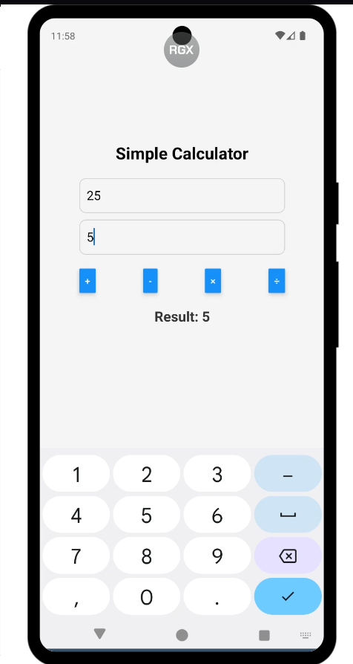

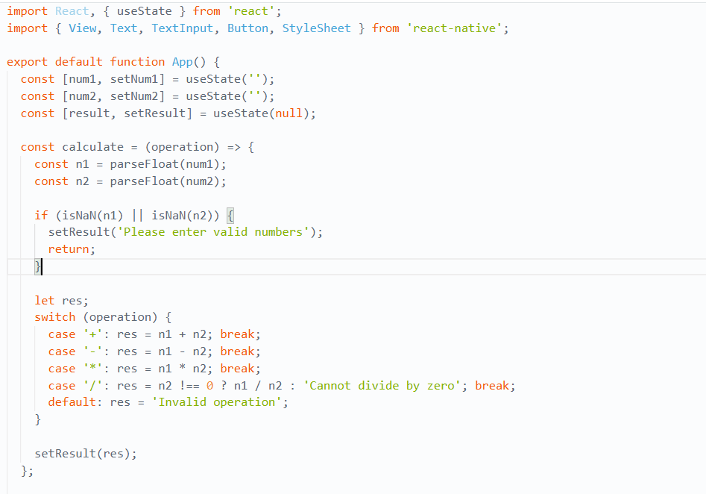Codes

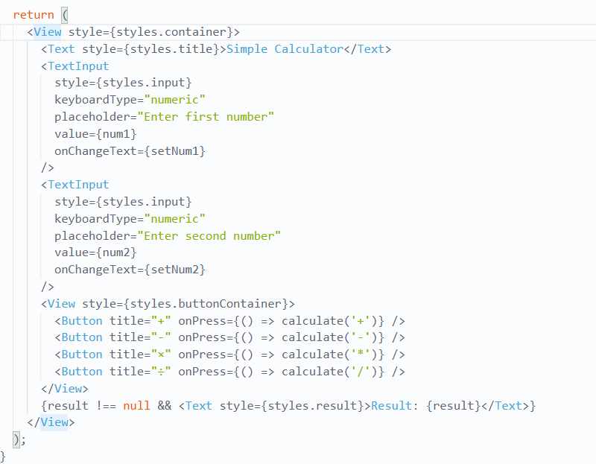Style that I put in

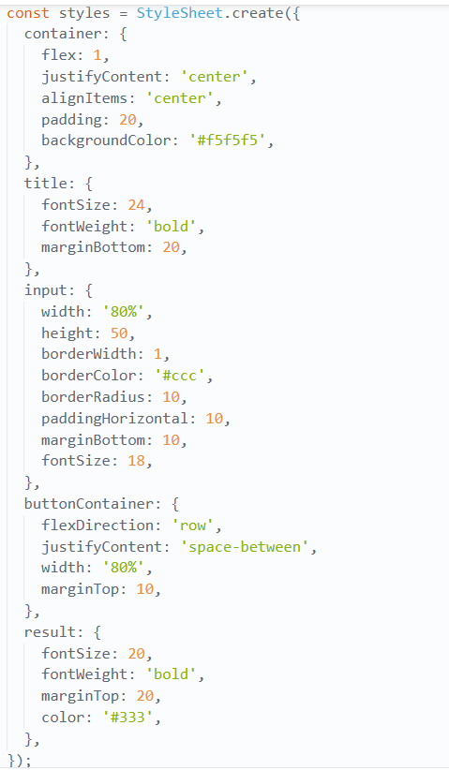

**Explain the code in short**

This React Native app is a simple calculator that inputs two numbers and executes the addition, subtraction, multiplication and division basic arithmetic operations. Also it use the useState hook to store the input values (num1, num2) as well as the calculation result. The calculate function takes in numbers or integers by converting input into numbers, and then carries out an operation, before it adds the result to the result. It also handles what error there could be like invalid input or divide by zero.

It has TextInput for number and Button components for operations and Text for the result. Using the StyleSheet guarantees you will have a clean (despite it being quite unstructured) layout, proper spacing, borders, and colors. In View, the buttons are laid horizontally, facilitating simple and quick calculations with a tap.

**References**

*Expo documentation*. (n.d.). Expo Documentation. <https://docs.expo.dev/>

Mallick, A. (2024, January 21). How to use Expo Snacks in React Native: Lft #2 - Aadil Mallick - Medium. *Medium*. <https://medium.com/@waadlingaadil/how-to-use-expo-snacks-in-react-native-lft-2-653853c9f503>

<https://github.com/ShlokManandhar5/Mobile_App.git>